1. You can bind all the events using angular which are made available by HTML attributes.
2. 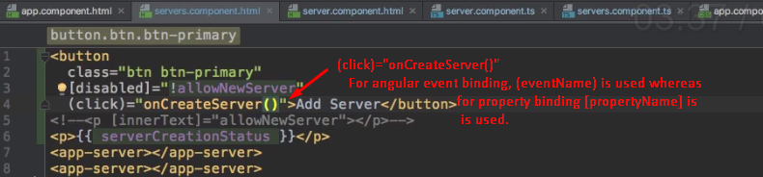
3. 